**Sensorized Glove Design**

A sensorized glove for teaching neck rehabilitation has been developed (Fig. 1). The purpose of the glove is to measure the forces and speeds applied by the hand to the neck during several neck rehabilitation exercises. The collected information will be used for teaching rehabilitation exercises to physiotherapist trainees. The sensorized glove components are:

1. The glove material is composed of two layers, the outer one is used for sensor installation and the inner one for sensor protection. The fabric of the outer layer is cotton-lycra, as it provides good elasticity and stretchiness to accommodate the different sensors of the glove. The fabric of the inner layer is cotton, as it provides the user with a comfortable and sweat absorbing material to be in contact with the hand.
2. Nineteen force sensitive resistors ((FSR) FSR 400, FSR 400 Short, and FSR 402, Interlink Electronics Westlake Village, CA, USA) are used for measuring the force applied by the hand. The palm of the hand and each of the phalanges was sensorized with an FSR (Fig. 2). The distal phalanx of the thumb and the right side of the palmar surface were sensorized with an FSR 402, as this sensor has a larger surface area.
3. One accelerometer (MPU-6050, InvenSense, San Jose, CA, USA) mounted on the back of the hand is used for measuring hand acceleration.
4. An electronic platform (Arduino Mega, Somerville, MA, USA) is used for handling signal acquisition and computer communication. This platform was chosen as it is easy to use and implement, it provides 16 analog inputs, 54 digital I/O, and it can be powered with the same USB cable used for computer interfacing, eliminating the need of an external power supply. The accelerometer is connected to the SDA and SCL digital inputs, and the FSRs are connected to the analog inputs of the Arduino. It is important to mention that since this Arduino only has 16 analog inputs and the glove has 19 FSRs, the FSR sensors I2, M2, and R3 were not connected. The decision of the sensor connections was made by an expert on physiotherapy.
5. Other electrical components are: flexible electrical wire (NEF26-10546, Cooner Wire, Chatsworth, CA, USA), ribbon cables, breadboard wire, breadboard ribbon connectors (2x8), DB15 connectors, 10KΩ resistors, and a breadboard.

**Software Design**

Figure 3 shows the custom software graphical user interface (GUI) developed to visualize the functioning of the sensorized glove. The GUI has a 2D view of the back of the right hand, with different areas representing the 19 FSRs installed on the glove. Each of these areas changes colour based on the force measured. The colour scale is displayed on the right side, going from O N to the maximum force used during calibration (default value is 10 N). The GUI allows the user to calibrate each of the FSRs (process explained in section XX), and save the force and acceleration data in a text file. The GUI also displays the status of the Arduino and the accelerometer and has a log to display important information about the functioning of the system.

**Calibration of the FSRs**

The FSRs need to be calibrated in order to provide meaningful force measurements. When force or pressure is applied to the sensor, its resistance changes following a linear pattern. Sensor calibration consists of applying known forces to the sensor while recording its corresponding resistance values. These data are used afterwards for calculating the linear parameters that relates resistance and force, by using linear regression algorithms. For the developed glove, in order to calibrate the FSRs a load cell (FRS166, Pressure Profile Systems, Los Angeles, CA, USA) is used (Fig. 4). The diameter of the load cell is quite larger than the sensing area diameter of the FSRs. In order to minimize calibration errors, calibration adapters were designed and 3D printed in order to provide an interface that matches properly the sensing area of the FSRs.

In order to calibrate a sensor, the user has to wear the glove and press on the load cell (ensuring the full area of the FSR is in contact with the calibration adapter) until the load cell reaches the maximum calibration force (the user can select the maximum amount of force desired for calibration in the GUI). Once the maximum force is reached, the software calculates the linear regression parameters for the calibration. If the intersection of the linear equation is less than ±0.5 N and if the coefficient of determination *r2* is more than ±0.92, the user will be notified that the sensor was calibrated correctly. This process has to be executed for all the FSR sensors.

Since the sensor response depends on the back support of the FSR when in contact with the hand, the calibration values may not be accurate if the glove is worn by another user or if the same user removes the glove and puts it back on. For these cases, calibration is recommended every time. The following section presents the force measurement assessment of the glove.

**Glove Force Sensing Assessment**

An experimental assessment was conducted in order to assess the performance of the glove for measuring forces accurately after calibration. Even though the glove has 19 FSRs, only two types of FSRs were used, the FSR 402 with a 14.7 mm diameter active area, and the FSR 400 (long and short) with a 5.6 mm diameter active area. Hence, the assessment was performed only for one of each of these sensors, specifically, the sensors located on T1 (FSR 402) and M1 (FSR 400 short). The following steps were performed for the assessment:

1. Each sensor was calibrated following the procedure described in section XX.
2. Immediately after calibration, without removing the glove, the user pressed on the load cell (ensuring that the full area of the FSR is in contact with the calibration adapter) until the load cell reached the maximum force. The user then released the pressure completely by lifting the finger. The step was repeated 5 times. During this step, force data measured by the FSR and the load cell were recorded. With the data recorded, the accuracy was calculated as the root mean square (RMS) of the difference between the FSR force and the load cell force.
3. Since the resistance of the FSRs is so high, when the sensors are under no load, the force values are always zero. Hence, in order to determine signal drift and noise, a static load was applied to each sensor for 10 minutes. Force values were recorded for the first and last minutes. These values were used for the noise and drift calculation.
4. The noise was calculated as the difference between the maximum and minimum values observed during the first minute. The drift was calculated as the difference between the average of the first 500 values of the first minute and the average of the last 500 values of the last minute.

The assessment results are presented in Table 1. The accuracy, noise and drift values for the FSR 402 were 0.43 N, 0.10 N and 0.27 N. Similarly, these values for the FSR 400 were 0.63 N, 0.11 N and 0.10 N respectively. The total errors for the FSRs sensors were 0.81 N and 0.84 N for the FSR 402 and the FSR 400 respectively.

|  |  |  |  |  |
| --- | --- | --- | --- | --- |
| FSR | Accuracy (N) | Noise (N) | Drift (N) | Total (N) |
| 402 | 0.43 | 0.10 | 0.27 | 0.81 |
| 400 | 0.63 | 0.11 | 0.10 | 0.84 |

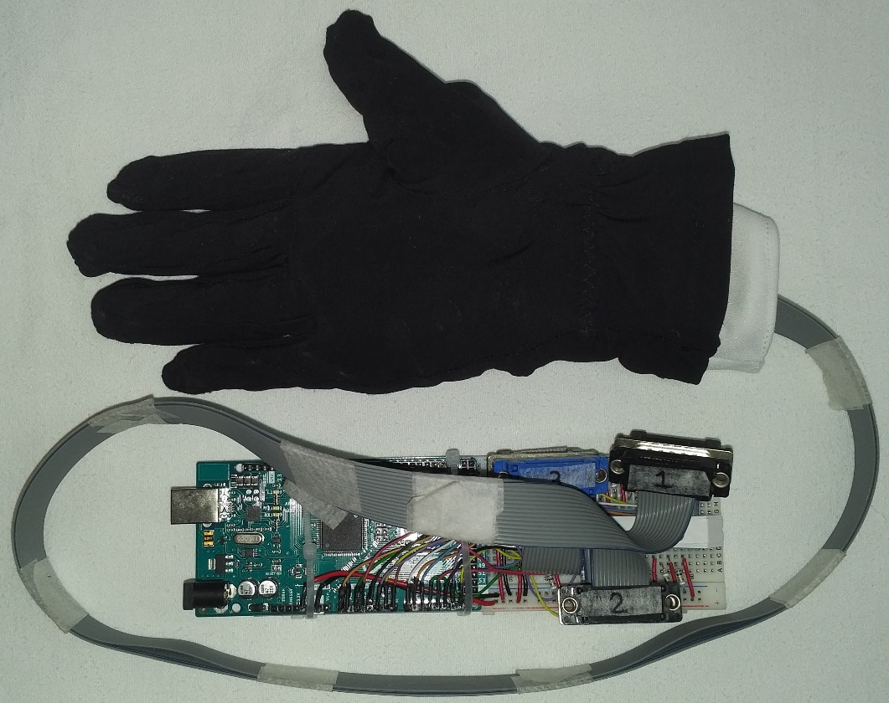

Figure 1. Sensorized glove and required electronics.

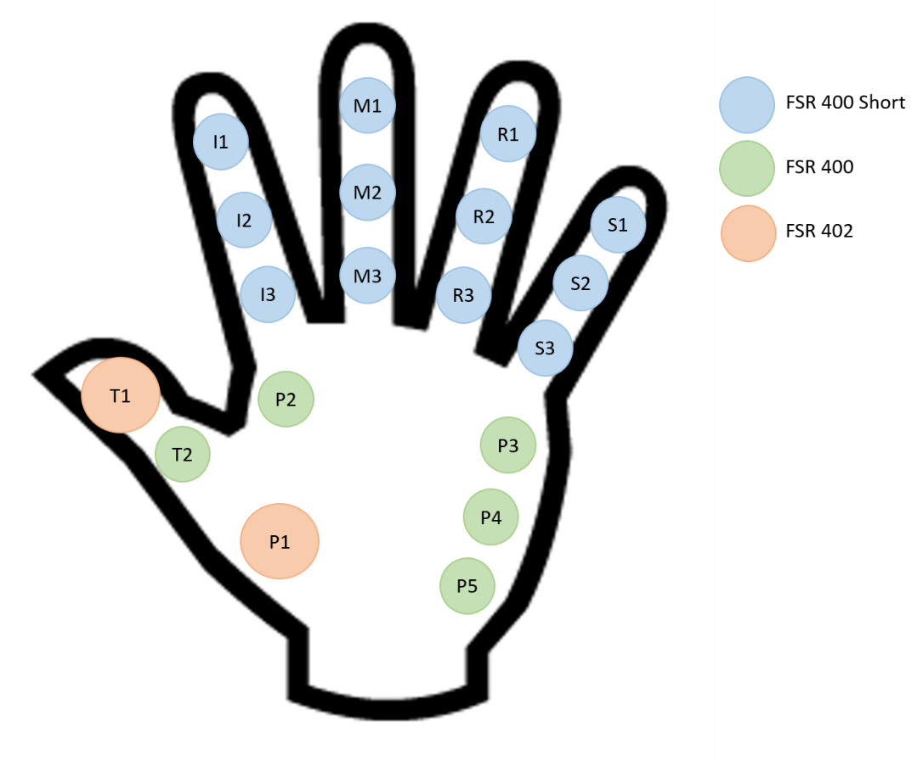

Figure 2. Location of the FSRs.

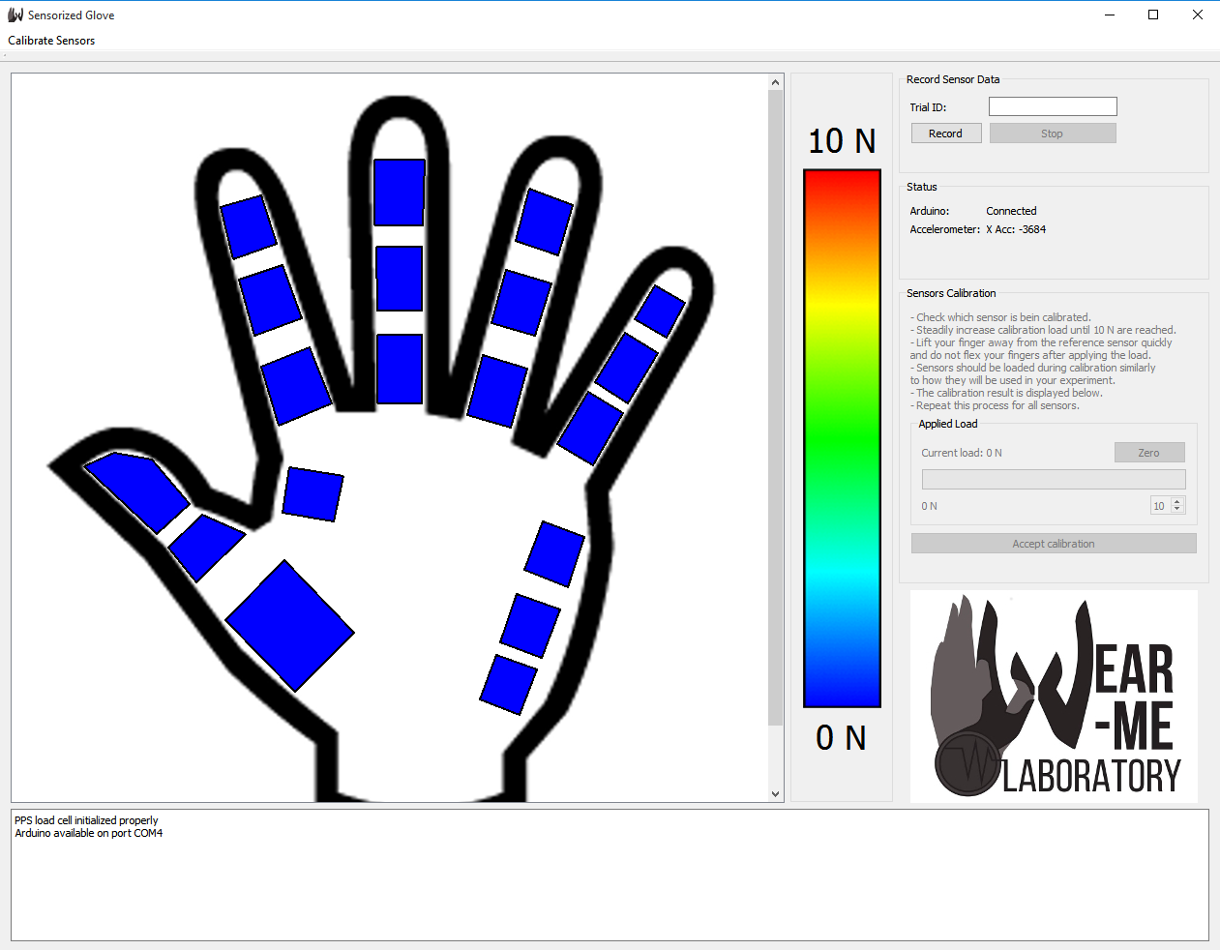

Figure 3. Custom software GUI of the sensorized glove.

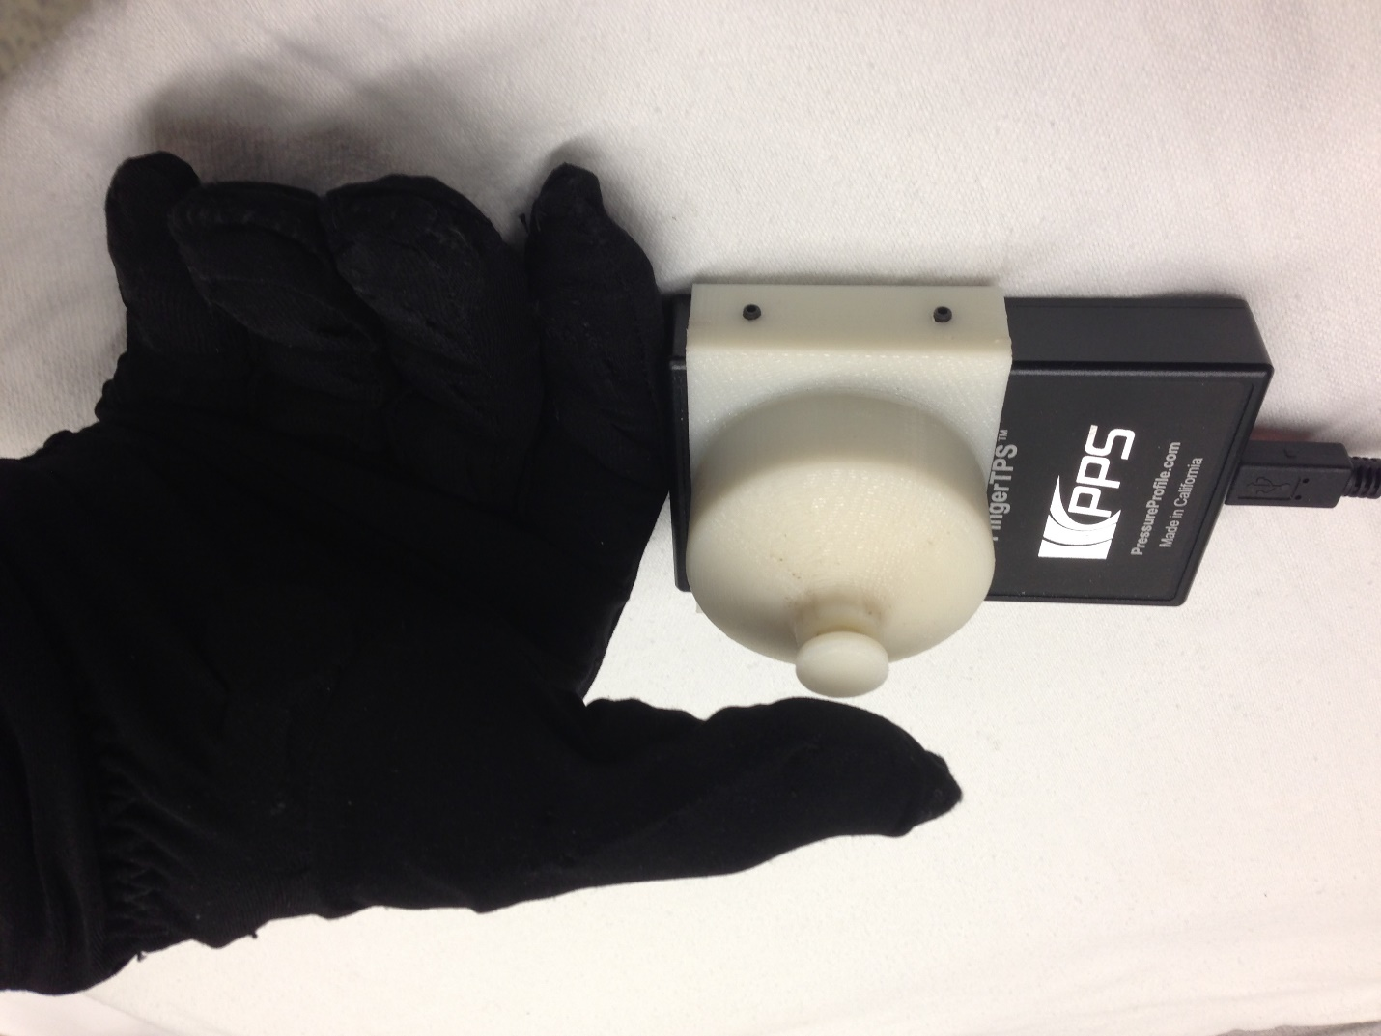

Figure 4. Load cell and calibration adapter used for calibrating the FSRs.